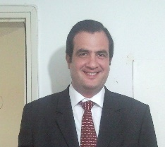
Benny Hochster
International Sales & Business Development

PERSONAL DATA
Age: 45
Languages: English and Hebrew –fluent. (Some understanding of German too)
Citizenship: USA / Israel / Germany

WORK EXPERIENCE

2006 - 2016:  VP Sales & Marketing  Maxco Business Development LTD  www.maxcobd.com | Responsible for all international sales activities.  Recruitment of new clients & maintaining existing clients.  Creation of sales venues – international distribution channels, local agencies.  Presentations, exhibitions & trade shows worldwide.  Market research, identification of opportunities and making connections.  High level long cycle negotiations.  Creation and design of marketing materials – including web based.
2004-2005  VP Sales & Marketing  OptiWay LTD  Netanya. | Led the company's marketing activities.  Defined sales and marketing targets and objectives.  Prepared Business and marketing plans for employees and investors.  Initiated and managed our relations with strategic partners, investors and customers.  Prepared and managed all marketing material.  Represented the company in exhibitions and trade conventions.
2000-2003  Business Development Manager (European Cellular Market)  OpticalAccess Inc.,  Jerusalem | Created and managed business relationships with nearly ALL European cellular operators.

EDUCATION

1999 - High Tech College, Herzeliya | Data communications
1996 - 1999 Bar Ilan University, Ramat Gan | B.Sc. in Chemistry

SKILLS
High personal motivation, independence, ambition, target oriented, excellent learning skills, keen analytical skills and conceptual understanding, strong team player, strategic thinker.

