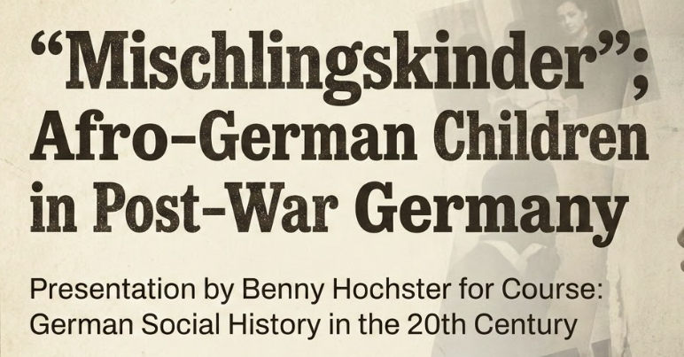
Presentation Overview
Core Subject
The treatment and marginalization of Afro-German “occupation children (Besatzungskinder)” in post war Germany, and what does their experience reveal about race, welfare institutions, and belonging?
Main Points I Discuss
1) Who were the “Mischlingskinder”?
How the issue came to be, as a result of US African-American soldiers stationed in Germany.
2) Mechanisms of Marginalization
The many ways these Mischlingskinder were marginalized in post war Germany
3) Lived Experience
The unique "double stigma" they suffered, as reflected in Memoirs such as Ika Hügel-Marshall’s "Invisible Woman"
4) Removal thru Adoption and Separation
In the 1950s, adoption abroad and kinderheime were used as "solutions to the problem". While masked as humanitarian , these were practically focused on removal from society.
5) Representation and Legacy
The film Toxi (1952) expressed sympathy without equality, reflecting conditional belonging. From the 1980s onward, Afro-German movements reframed these children from welfare “cases” into historical subjects.

