לימוד עצמי ליום רביעי.
ניתן לעבוד בזוגות אבל כל ילדה ממלאת דף עבודה משלה וגם עובדת בחוברת שלה.
- פתחי את הספר לעמוד 11.
- תקראי את המשפטים למטה ותמלאי את החסר על פי המידע שבתרגיל 4 שבעמוד 11. הסתכלו רק תרגיל 4 שבעמוד 11 ואז תוכלי למלות את המשפטים למטה.
Adi has 10 shekels. She is hungry. She goes to markets to buy food for ten shekels.
1. Adi is at the Carmel Market. Where is the Carmel Market? ________________
She wants falafel. With 10 shekels, she can buy _____________________
2. Now Adi is in Acco. She goes to the _______________________________.
She has ten shekels and she can buy _____________________.
How many pieces can she buy? ________________________
3. Now Adi is in the Machane Yehuda Market. Where is that? _______________
With ten shekels, Adi can buy a _______________________.
What kind of sandwich do you think she should get? Tuna? Cheese? Avocado?
4. Are you hungry? Here is 10 shekels!!!
Choose(תבחרי) something to buy from page 11. What is it? ____________________
Where can you buy it? הקיפו את התשובה הנכונה Acco Tel Aviv Jerusalem
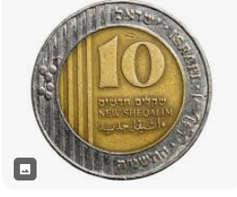
3. הסתכלי בעמוד 12 תרגיל B
מלאו את הפיסקה עם המילים המתאימים:
Findlay Market
favorite buy ages money places
Finlay Market is in Cincinnati, USA. More than a million people of all ____________________ come to this market every year. They ______________apples, avocados, bananas and much more. There are also nice _________________ to eat at the market. Many people say that Findlay Market is their ___________________ place because you don’t need a lot of __________________ to have a great day.
4. עשי עמודים 8.9.10 בחוברת עבודה.

