24 Nov 2014

To: Mr. Charles Ciminesi III From: Benny Hochster
Tax Compliance Officer SSN: 063-98-7919
EID: 1000850082 13 Katlav st. Apt 11
801 Civic Center Drive West Bet Shemesh, Israel 99000
Suite 200 M/S 6105 Phone: +972-54-8040040
Santa Ana, CA 92701-4066 mail: bhochster@gmail.com

Via Fax: +1-877-256-2041
-----------------------------------------------------------------------------------------------------
Dear Mr. C. Ciminesi III,
This fax comes continuing our phone conversation from last Thursday.
First I would very much like to thank you full heartedly for your assistance, and prompt replies you gave my question. It is wonderful knowing there are people in the system as helpful and kind as you are.
The following is a summary of my thoughts on the issue at hand.
As you no doubt remember, I have told you I have already been examined a couple of years ago, regarding the years 2006,2007,2008.
I have complied with all the requirements and the case have come to satisfactory resolution.
To my surprise I have learned last week, that my subsequent reports, years 2009, 2010, 2011, were also submitted to you for examination, resulting in your request for almost identical documentation to the one I supplied back in 2010.
I realize of course this is no one's fault, and this is probably a result of a bureaucratic mistake. Nevertheless, it is very inconvenient for me. This is especially true, considering the fact me and my wife live and work in Israel, hence almost all the documents are in Hebrew, and need to be notarized an translated prior to submission. A process not only hard and tedious, but also very expensive (the cost of EACH PAGE translated and notarized is around $80 !!) .
If indeed this current examination is a result of someone not updating my status somewhere, I would ask you to consider the possibility to have this mistake rectified asap.

Continued…….
In the mean time I am sending you (by fax) copies of many of the documents I have sent to comply with the requests for documents I received during my last examination. All these documents were sent after being notarized and translated to my former examiner. Her details are:
Name: Juhenny A. Blanco Soto
Employee ID: 313916
Phone: 787-522-1906
Fax: 787-522-1742
IRS Office: 48 Carr 165, Suite 165, Guaynabo, PR 00968-8000

Please contact her to verify all the above.

In the next page the is a table of contents and a short explanation to all the attached documents.
Kindly, Please confirm receiving this batch of documents. My contact details are below.

Thank You & Best Regards,
Benny Hochster
SSN: 063-98-7919
Phone : +972-54-80-400-40

Document Content of this FAX

Group A
To verify my Identity and citizenship

Document #1: US Passport
p. 1: Copy of my passport (English)

Document #2: My US birth certificate
p. 1: Copy of my birth certificate (English)

Document #3: My Social Security card
p. 1: Copy of my Social Security card (English)

Document #4: My Israeli Passport.
p. 1: Copy of my Israeli Passport (Dual Language Hebrew/English)

Group B
To verify my wife Ronit and I are indeed married

Document #5: My Wife's Israeli Passport
p. 1: Copy of Ronit Hochster's Israeli passport (Dual Language Hebrew/English)
p. 2: Copy of page six in her passport (Name change) (Dual Language
Hebrew/English)

Document #6: Our marriage certificate
p. 2 Translation of marriage certificate
p. 3: Copy of marriage certificate (Hebrew)

Group C
To substantiate my children's, Identity, Citizenship, Dates of Birth and being, in fact, our children

Subgroup C1
Yoav Avraham Hochster, Social Security No. 063-98-9687

Document #7: Yoav's Passport and Social Security card
P. 1: Copy of Yoav's Passport and Social Security card (English)

Document #8: Yoav's birth certificate
p. 1: Copy of Yoav's birth certificate (Dual Language Hebrew/English)

Subgroup C2
Yael Hochster, Social Security No. 063-98-9692

Document #9: Yael's Passport and Social Security card
P. 1: Copy of Yael's Passport and Social Security card (English)

Document #10: Yael's birth certificate
p. 1: Copy of Yael's birth certificate (Dual Language Hebrew/English)

Subgroup C3
Shira Emuna Hochster, Social Security No. 063-98-9690

Document #11: Shira's Passport and Social Security card
P. 1: Copy of Shira's Passport and Social Security card (English)

Document #12: Shira's birth certificate
p. 1: Copy of Shira's birth certificate (Dual Language Hebrew/English)

Subgroup C4
Gilad David Hochster, Social Security No. 063-98-9683

Document #13: Gilad's Passport and Social Security card
P. 1: Copy of Gilad's Passport and Social Security card (English)

Document #14: Gilad's birth certificate
p. 1: Copy of Gilad's birth certificate (Dual Language Hebrew/English)

Group D
To establish my Children's living with me, and dependence on me.

Document #15: Explanation letter on Residence Address, Medical and School Records

Document #16: Registry Extract from the Israeli Civil Registry
P 1: Translation of the summary of registration in the Israeli Civil Registry
p. 2: Translation of the Continuation of the summary of my registration in the Civil
Registry
p. 4: Copy of the summary of registration in the Israeli Civil Registry (Hebrew)
p. 5: of the Continuation of the summary of my registration in the Civil Registry

Subgroup D1
Yoav A. Hochster

Document #17: Medical record of Yoav, from the year 2008 (stating his address) p. 1: Translation of a clinic visitation confirmation, from the year 2008
p. 2: Copy of a clinic visitation confirmation, from the year 2008 (Hebrew)

Document #18: Medical record of Yoav, from the year 2007 (stating his address) p. 1: Translation of a clinic visitation confirmation, from the year 2007
p. 2: Copy of a clinic visitation confirmation, from the year 2007 (Hebrew)

Document #19: Medical record of Yoav, from the year 2006 (stating his address) p. 1: Translation of a clinic visitation confirmation, from the year 2006
p. 2: Copy of a clinic visitation confirmation, from the year 2006 (Hebrew)

Document #20: School Record for Yoav, for the years 2006, 2007, 2008.
p. 1: School letter confirming Yoav attended 2st to 3rd grades in the years 2006-2008 (English)

Subgroup D1
Yael Hochster

Document #21: Medical record of Yael, from the year 2008 (stating her address) p. 1: Translation of a clinic visitation confirmation, from the year 2008
p. 2: Copy of a clinic visitation confirmation, from the year 2008 (Hebrew)

Document #22: Medical record of Yael, from the year 2007 (stating her address) p. 1: Translation of a clinic visitation confirmation, from the year 2007
p. 2: Copy of a clinic visitation confirmation, from the year 2007(Hebrew)

Document #23: Medical record of Yael, from the year 2006 (stating her address) p. 1: Translation of a clinic visitation confirmation, from the year 2006
p. 2: Copy of a clinic visitation confirmation, from the year 2006 (Hebrew)

Document #24: School Record for Yael, for the years 2007, 2008.
p. 1: School letter confirming Yoav attended 1st to 2rd grades in the years 2007-2009 (English)

Subgroup D3
Shira E. Hochster

Document #25: Medical record of Shira, from the year 2008 (stating her address) p. 1: Translation of a clinic visitation confirmation, from the year 2008
p. 2: Copy of a clinic visitation confirmation, from the year 2008 (Hebrew)

Document #26: Medical record of Shira, from the year 2007 (stating her address) p. 1: Translation of a clinic visitation confirmation, from the year 2007
p. 2: Copy of a clinic visitation confirmation, from the year 2007 (Hebrew)

Document #27: Medical record of Shira, from the year 2006 (stating her address) p. 1: Translation of a clinic visitation confirmation, from the year 2006
p. 2: Copy of a clinic visitation confirmation, from the year 2006 (Hebrew)

Subgroup D4
Gilad D. Hochster

Document #28: Medical record of Gilad, from the year 2008 (stating his address) p. 1: Translation of a clinic visitation confirmation, from the year 2008
p. 2: Copy of a clinic visitation confirmation, from the year 2008 (Hebrew)

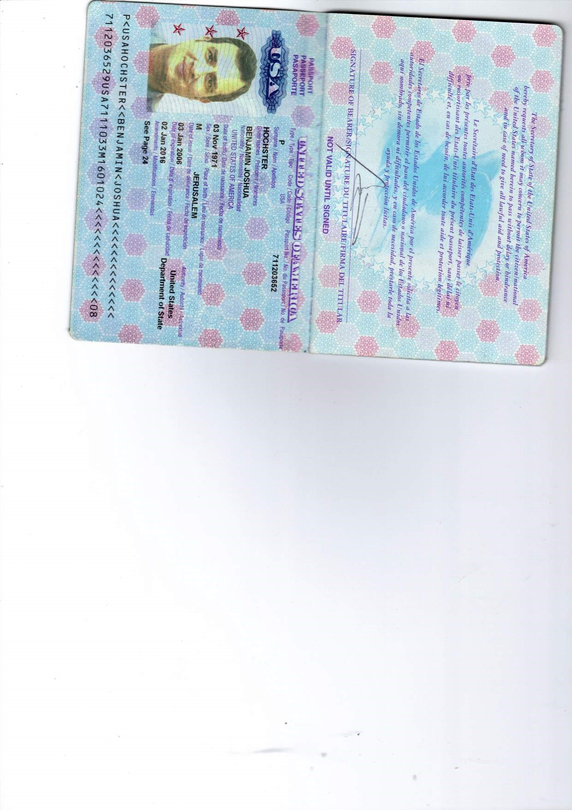


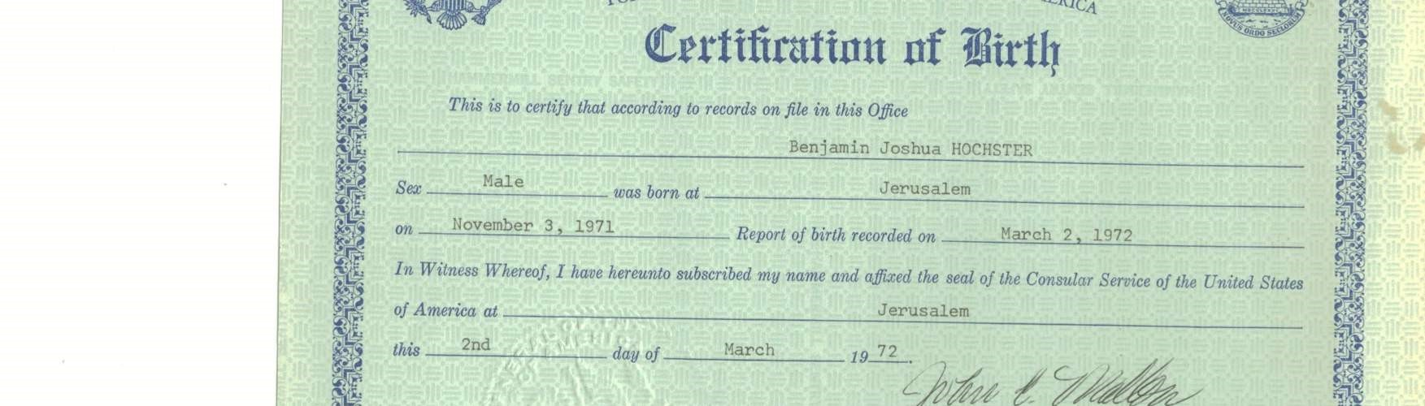
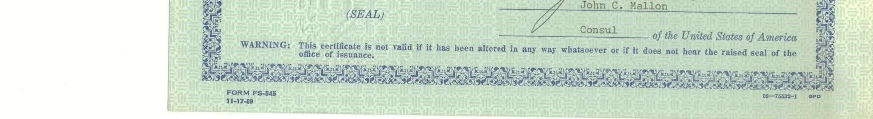



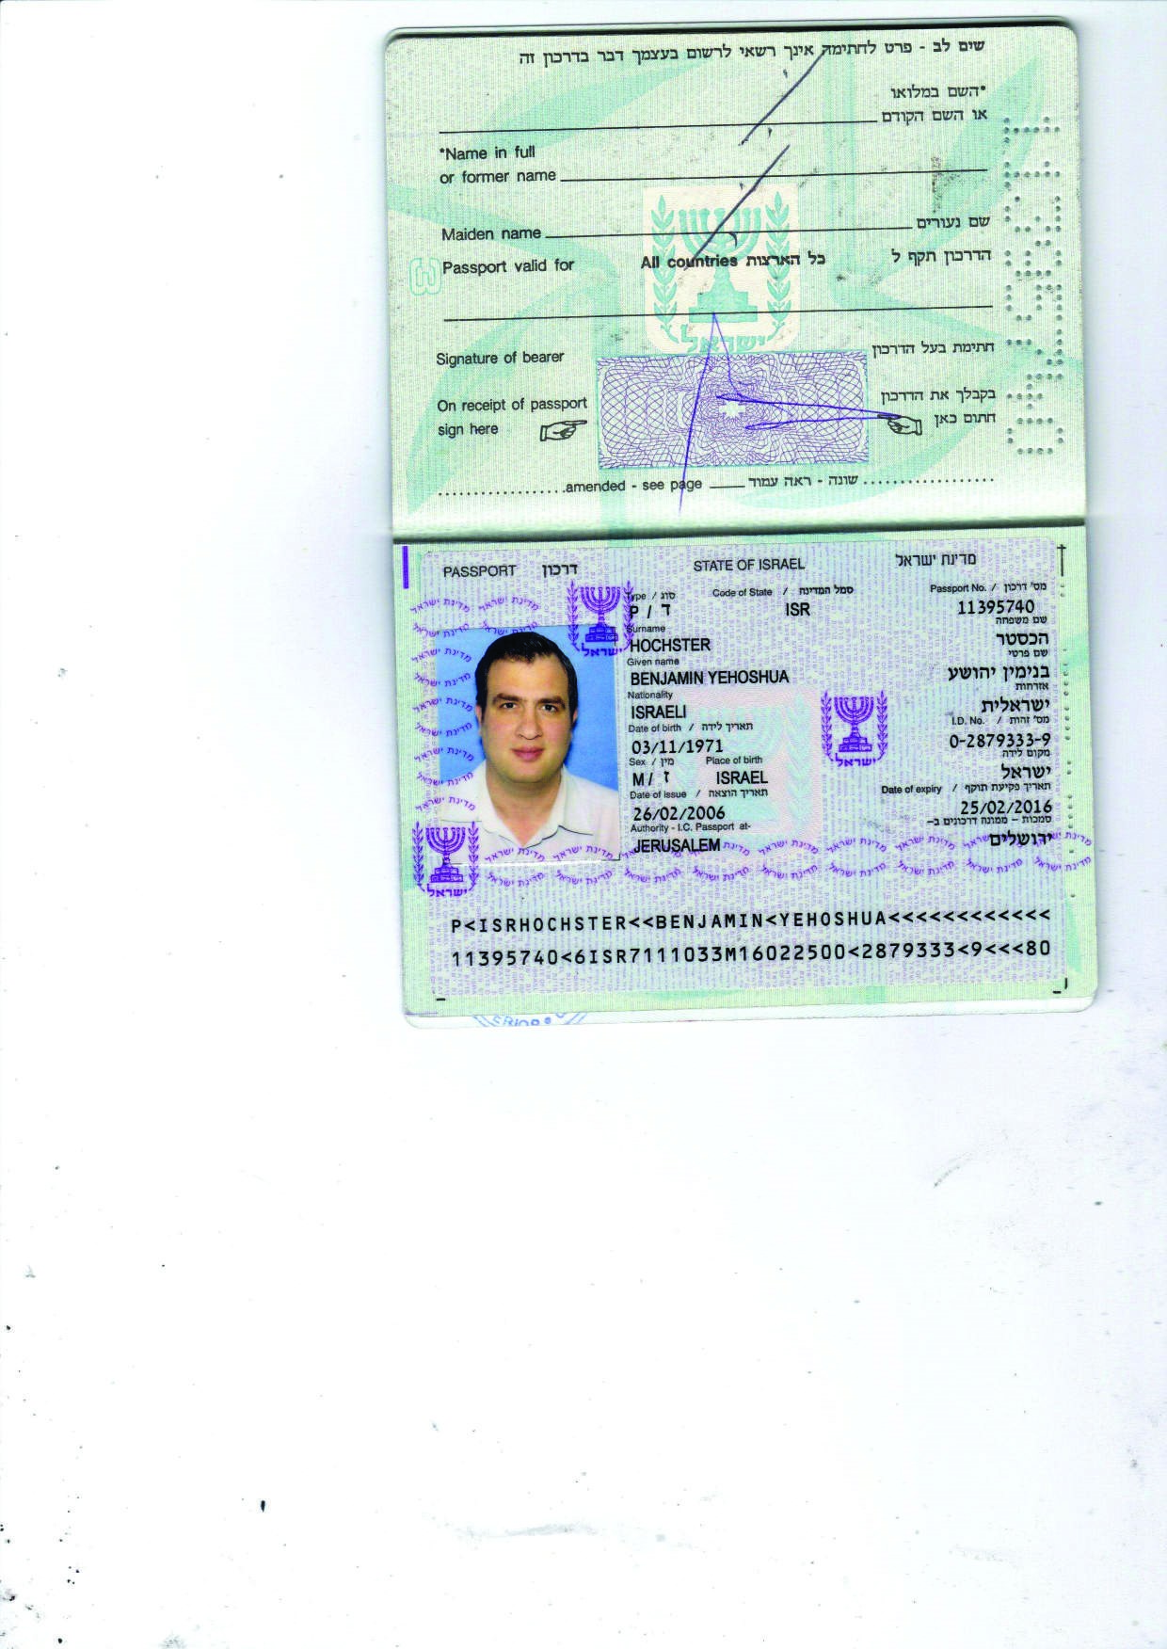

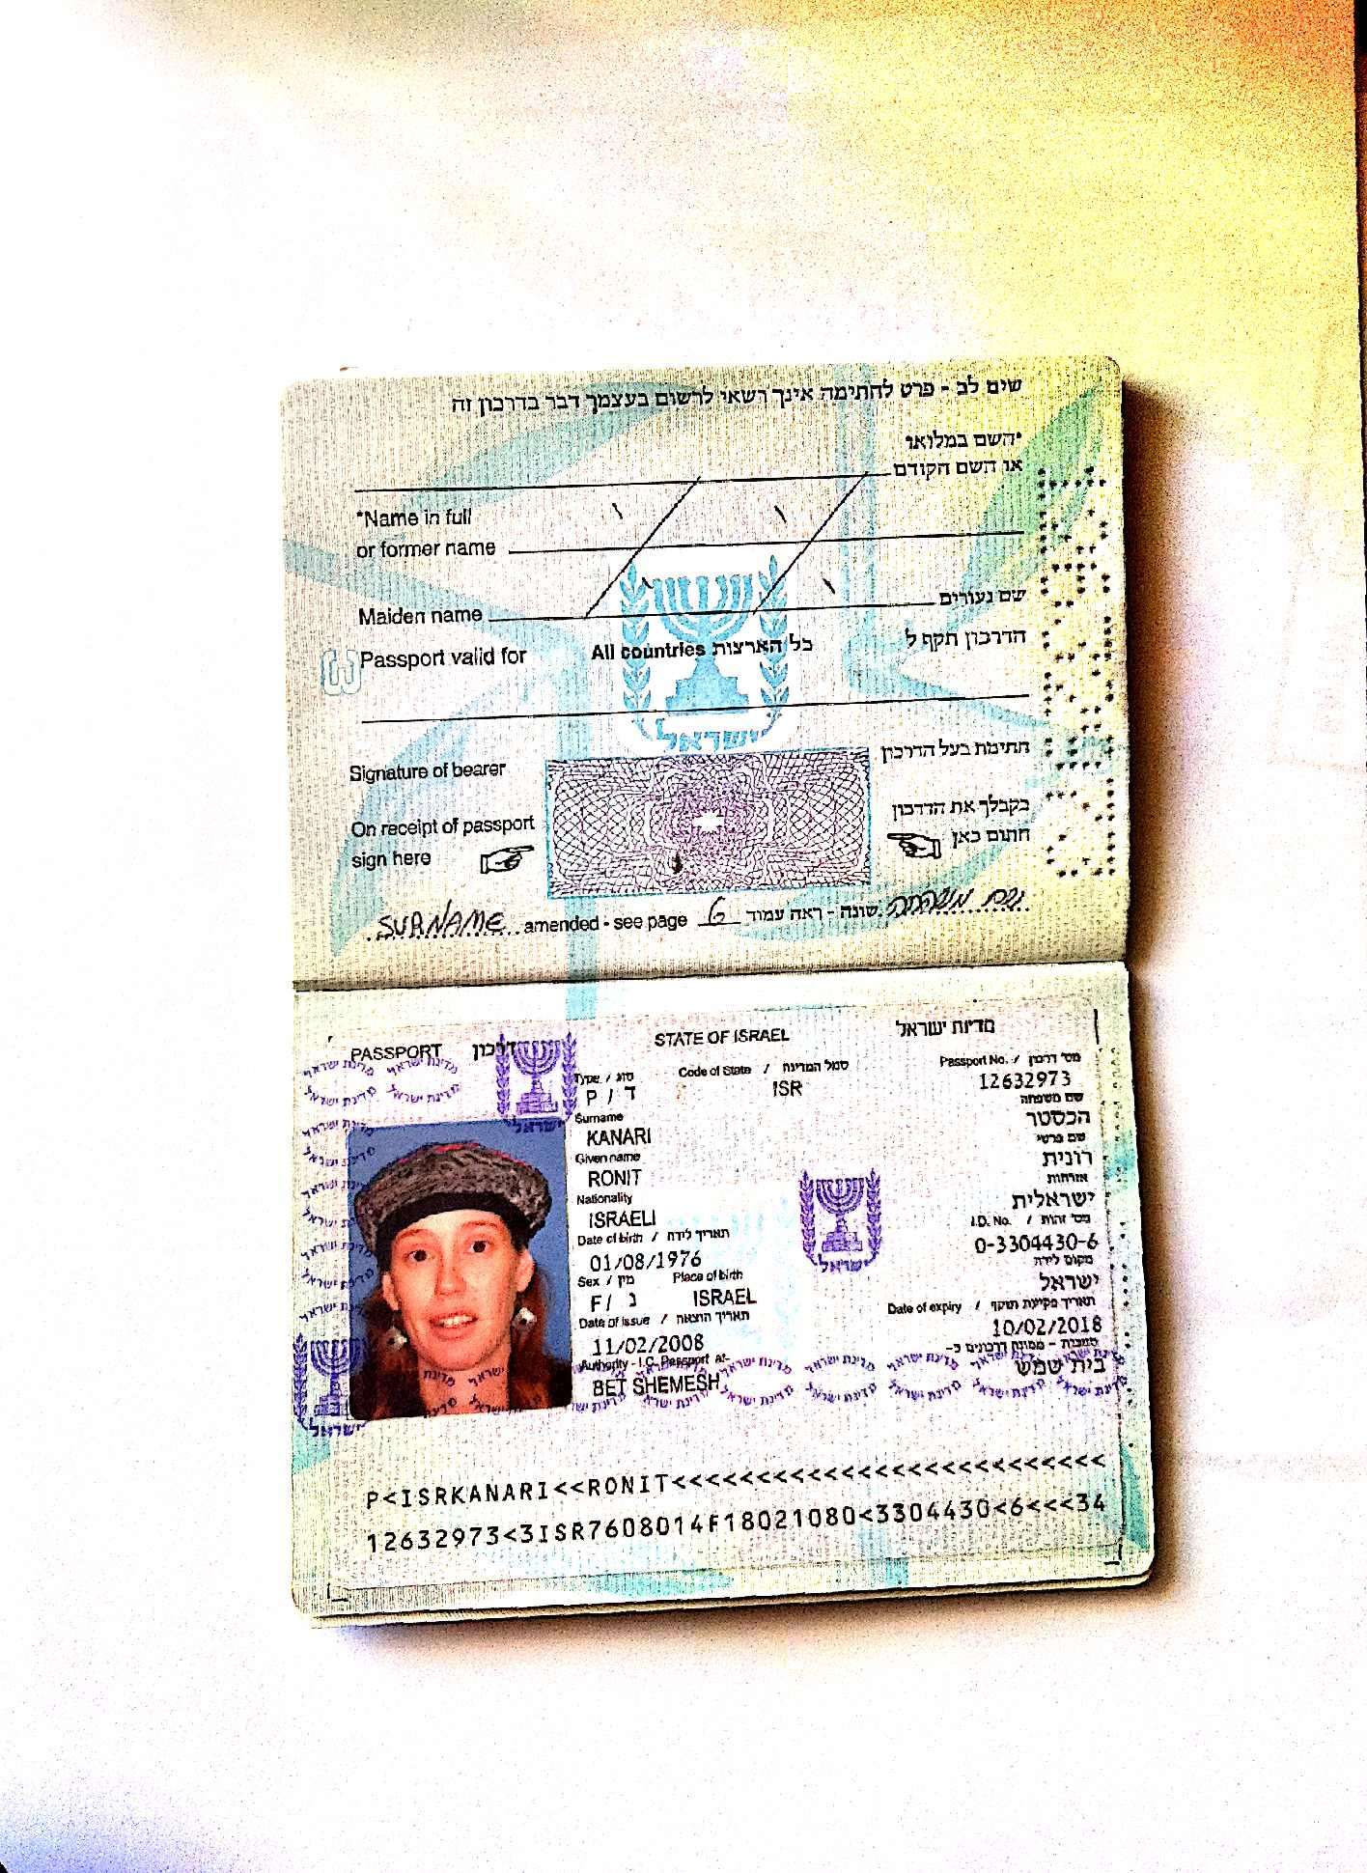
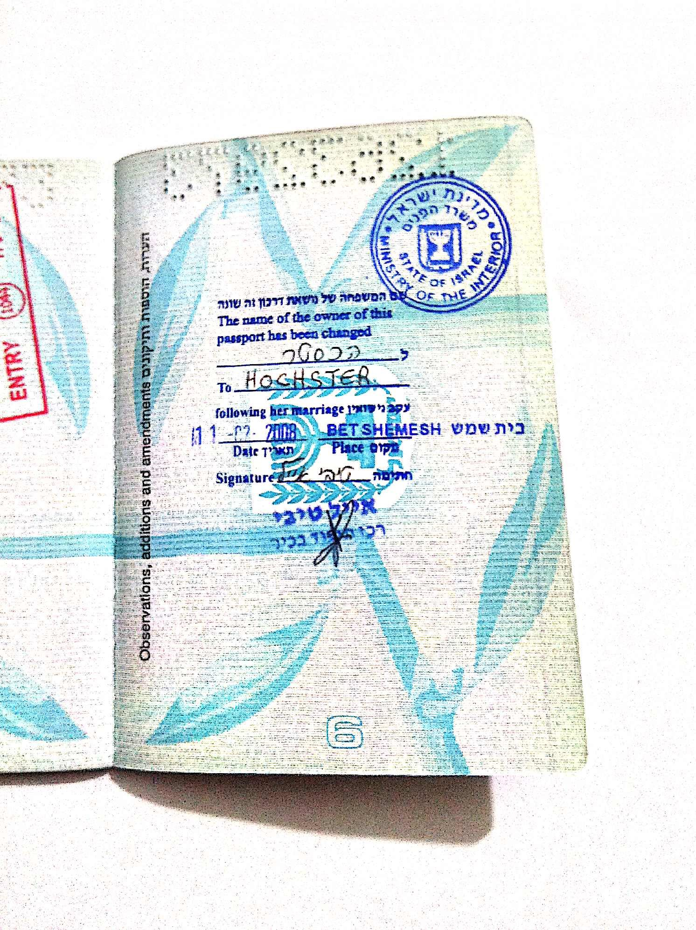
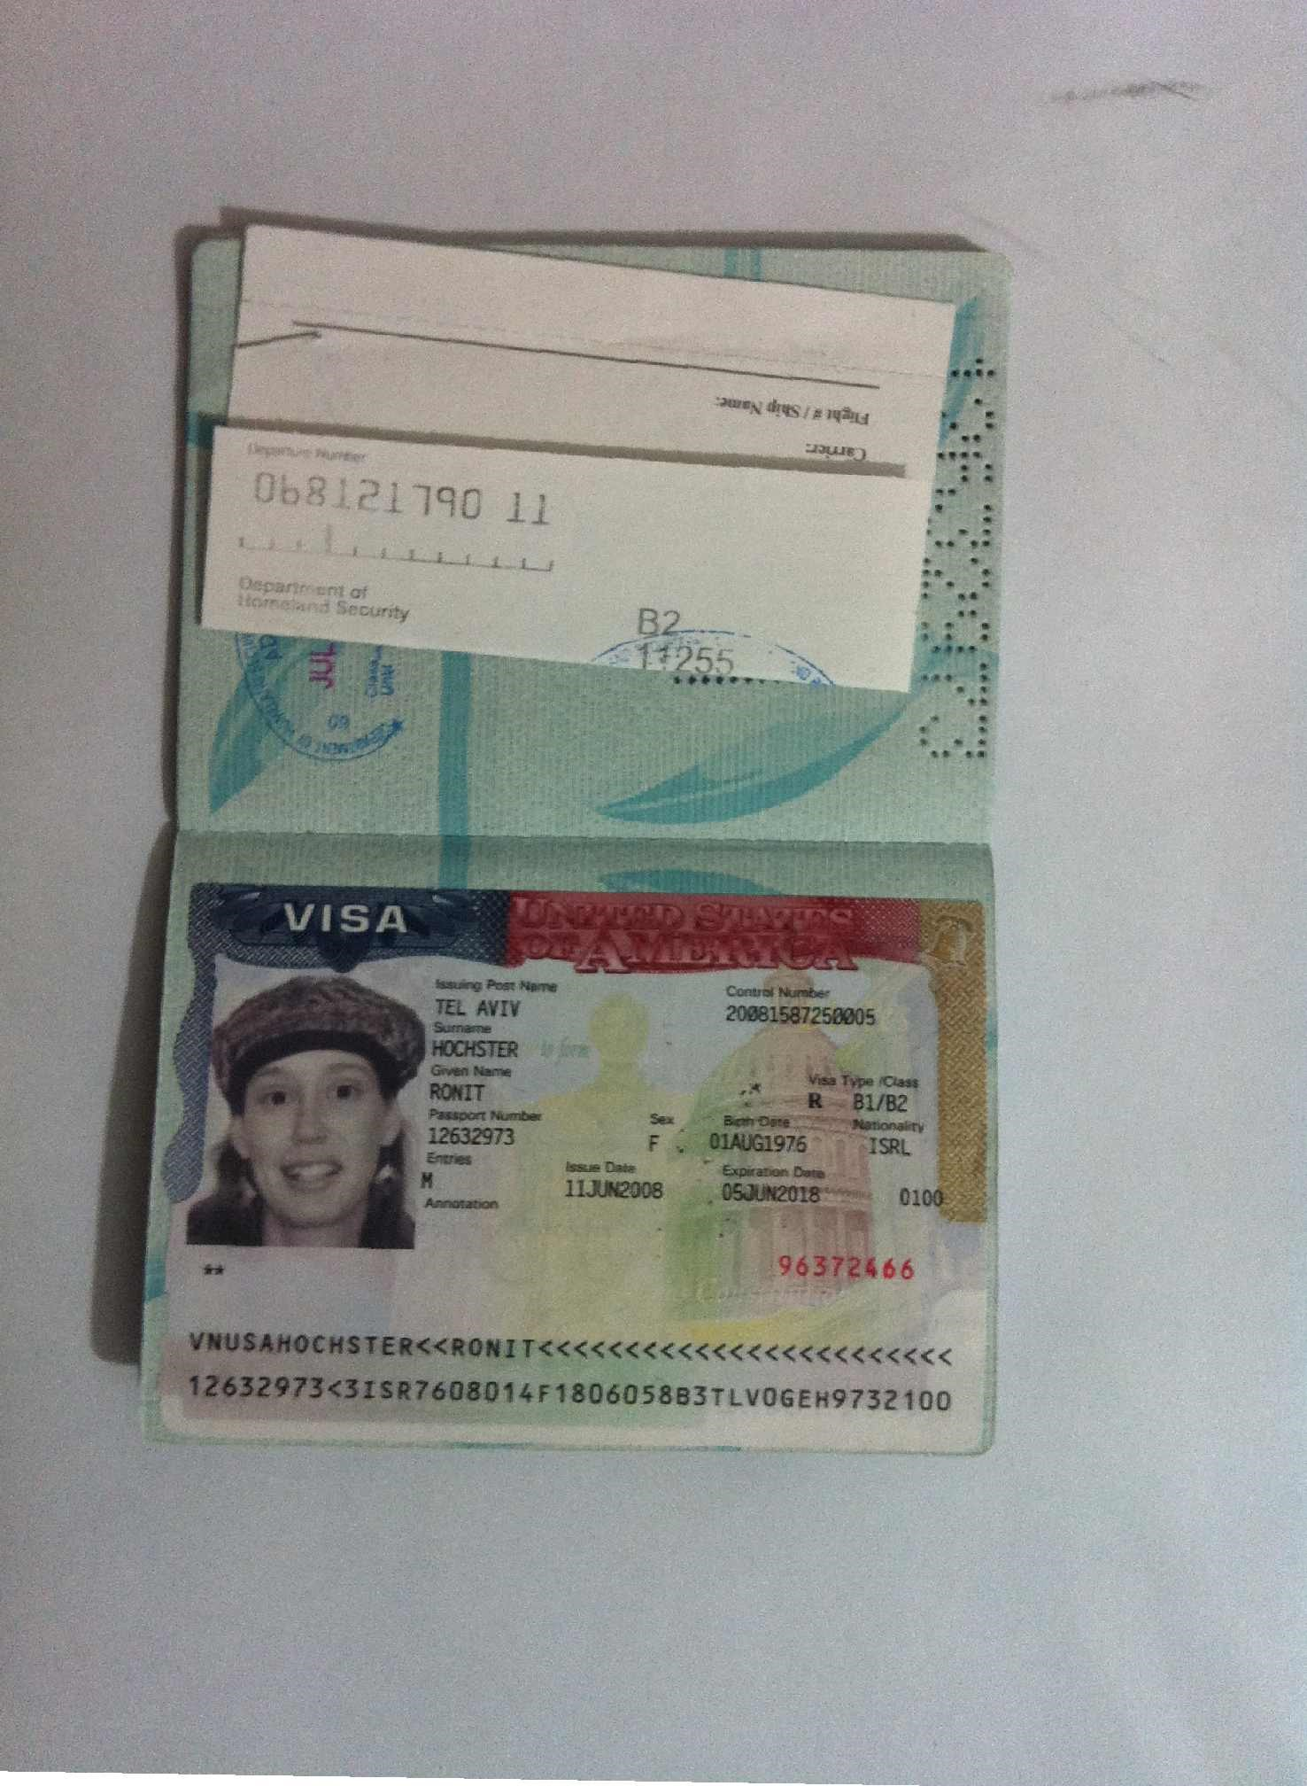
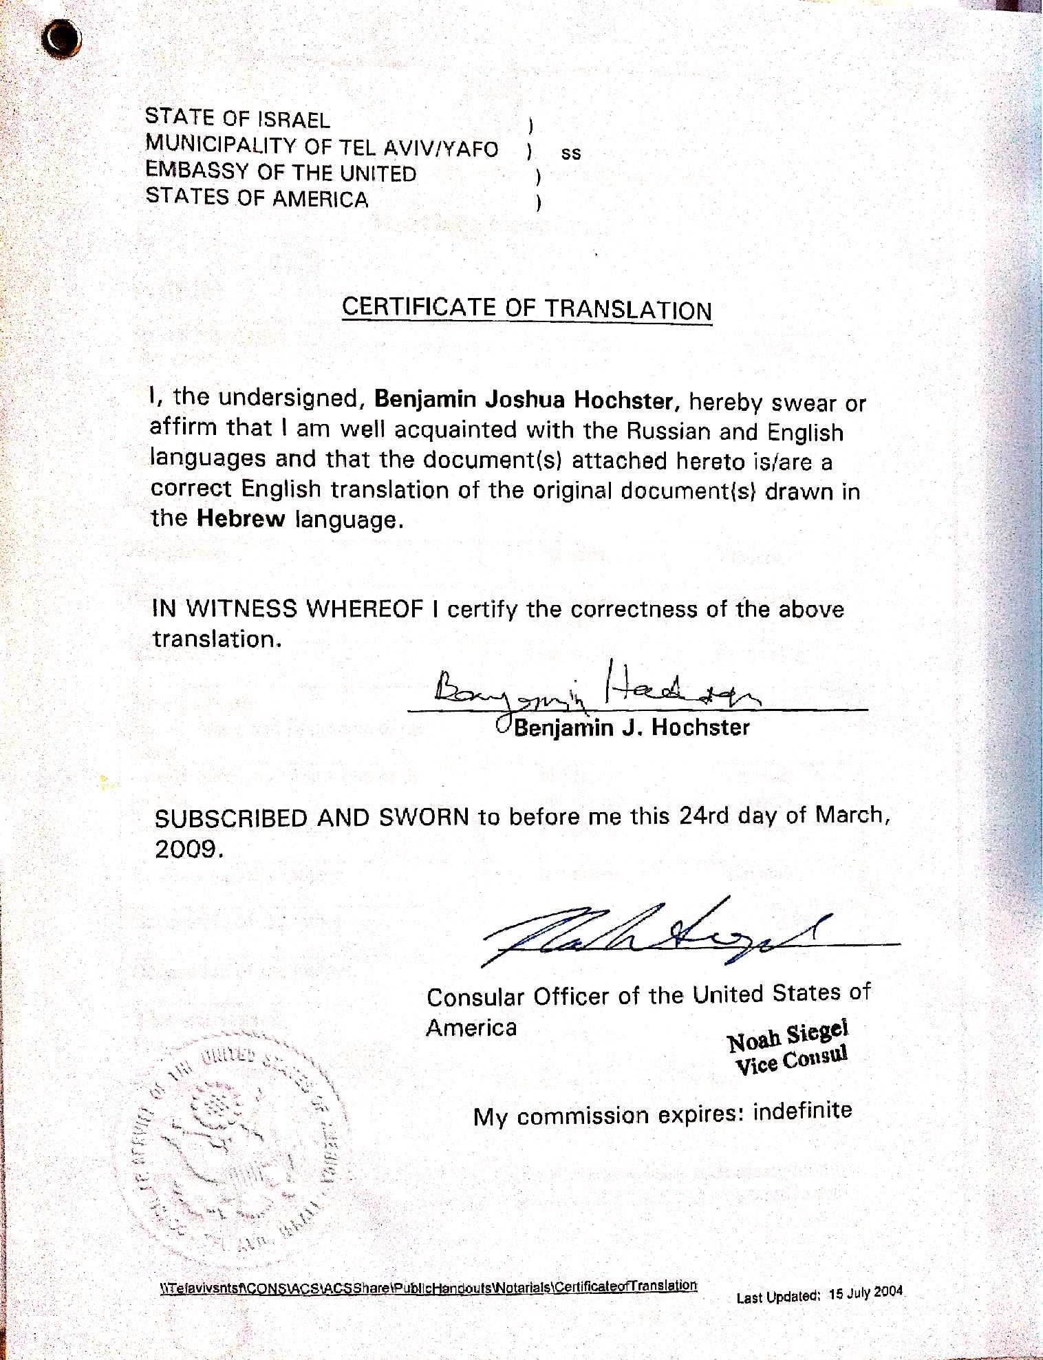
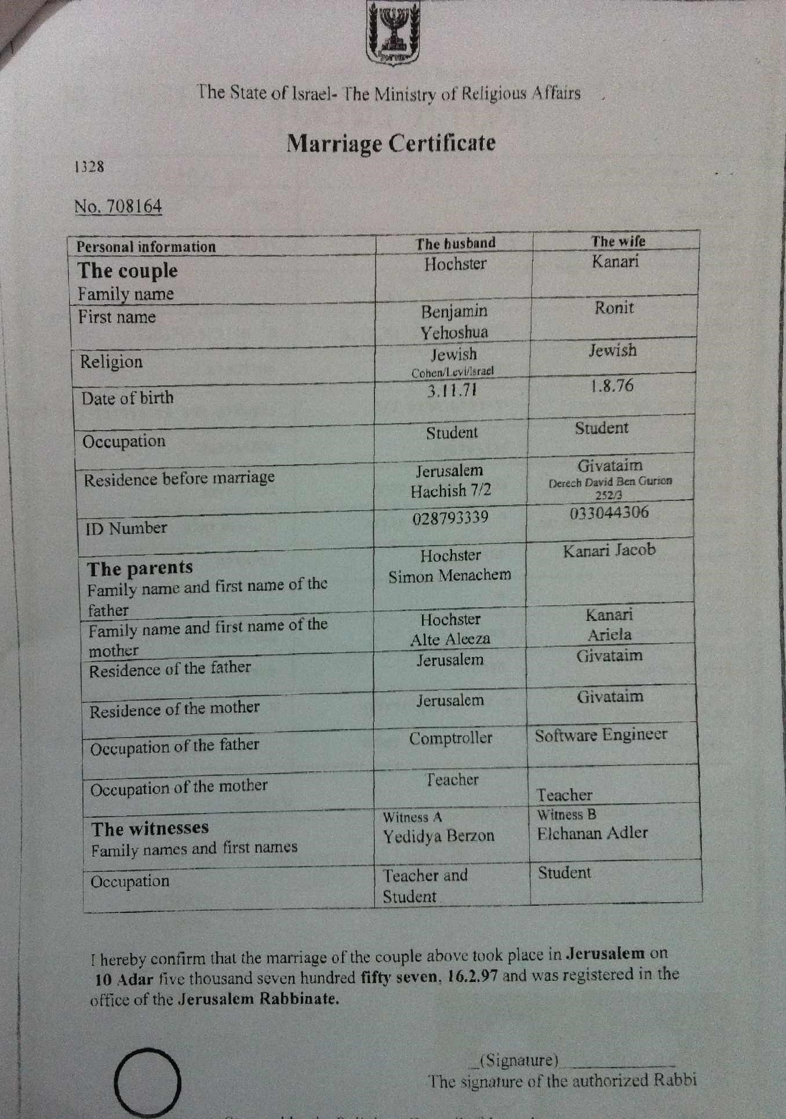
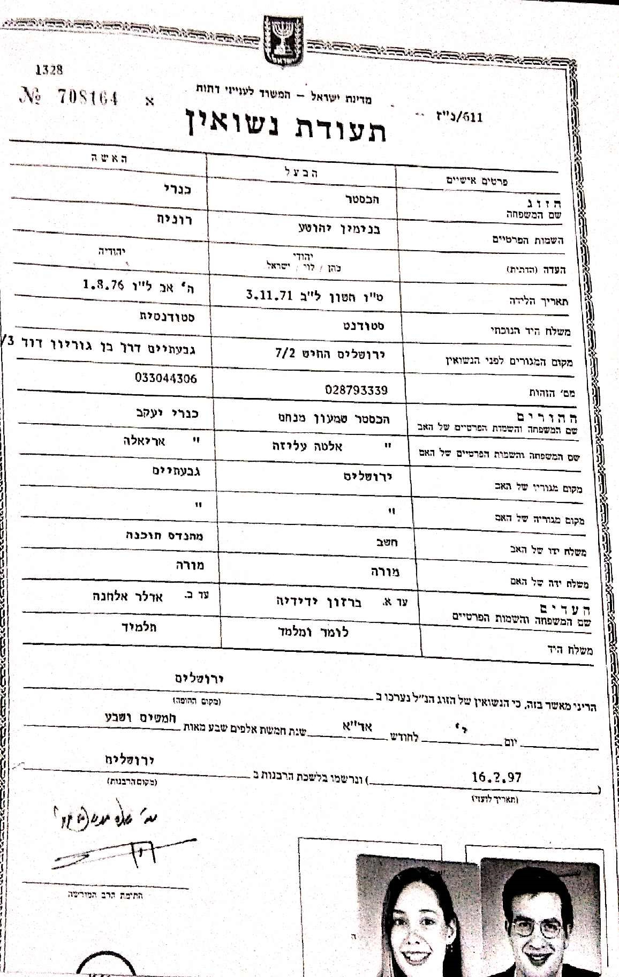

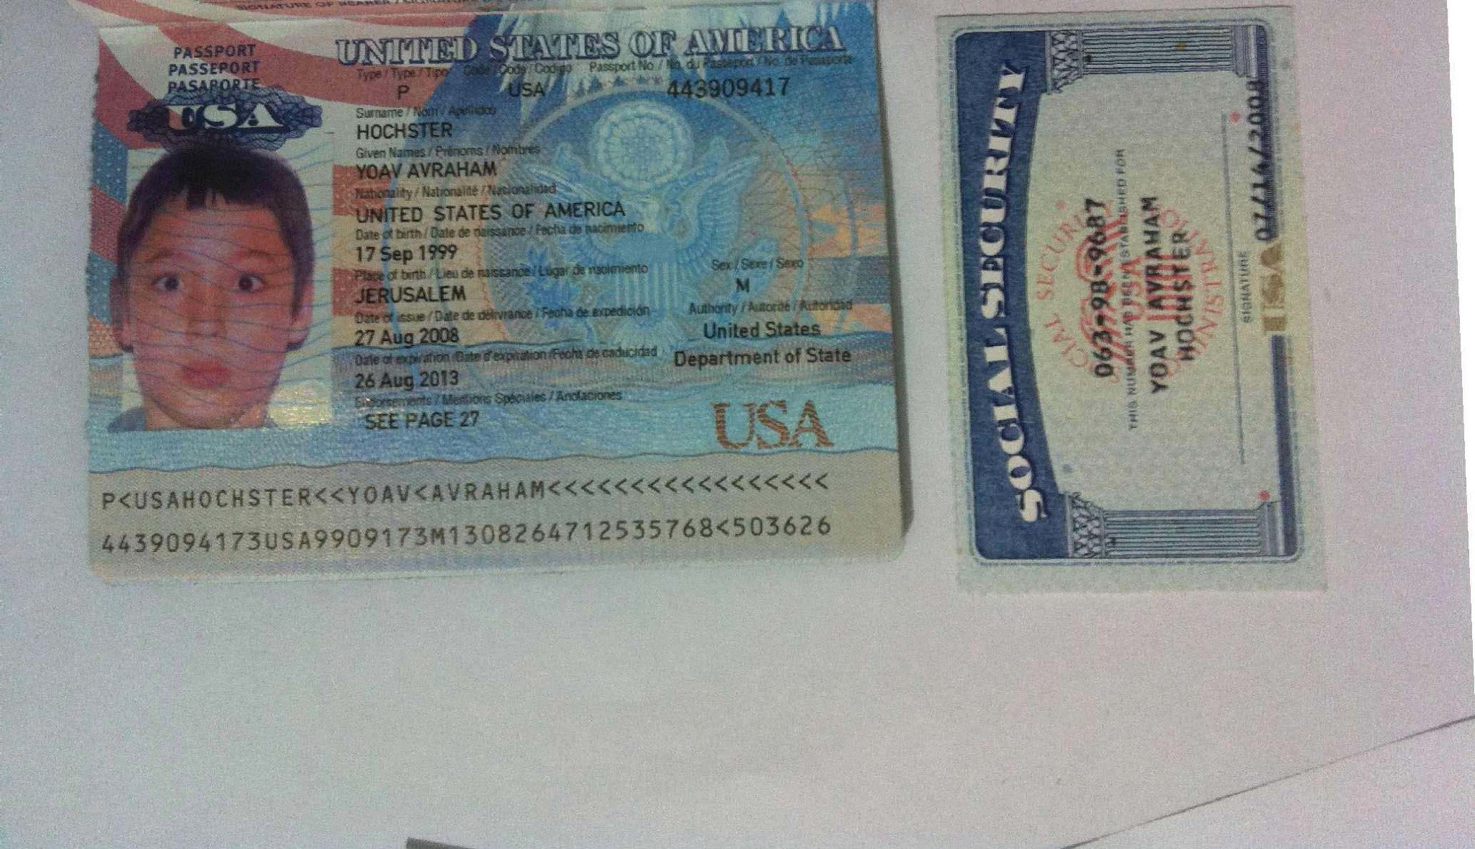
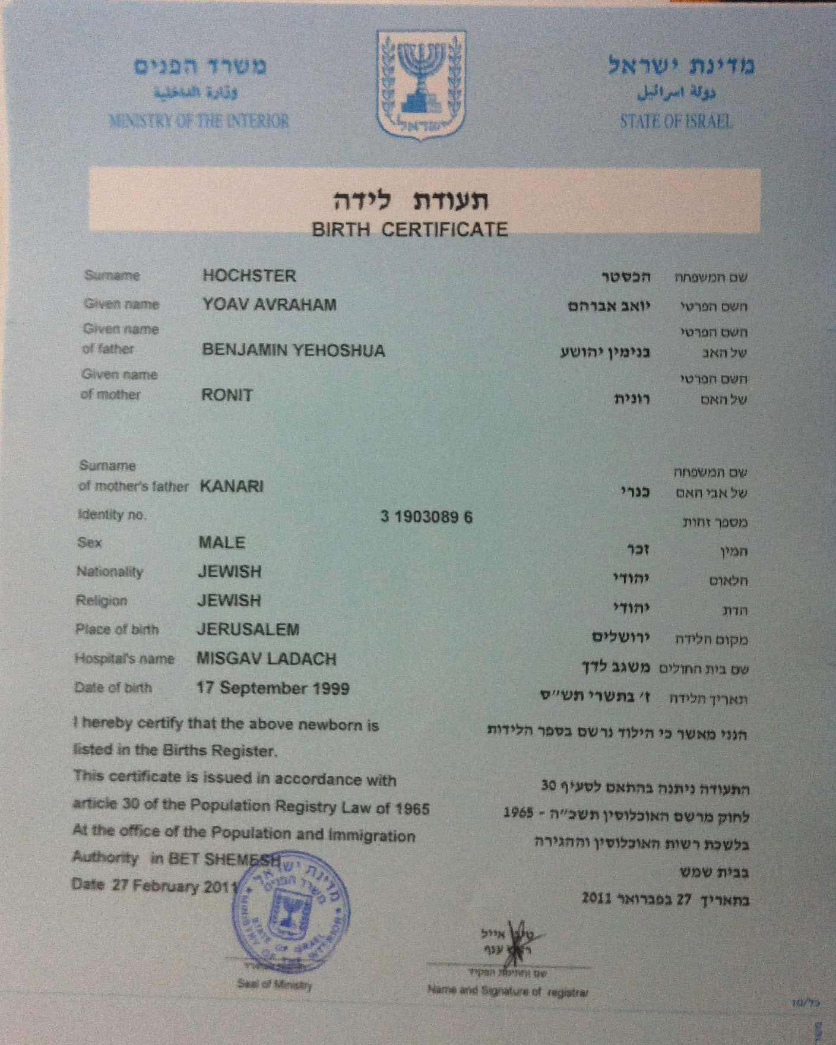
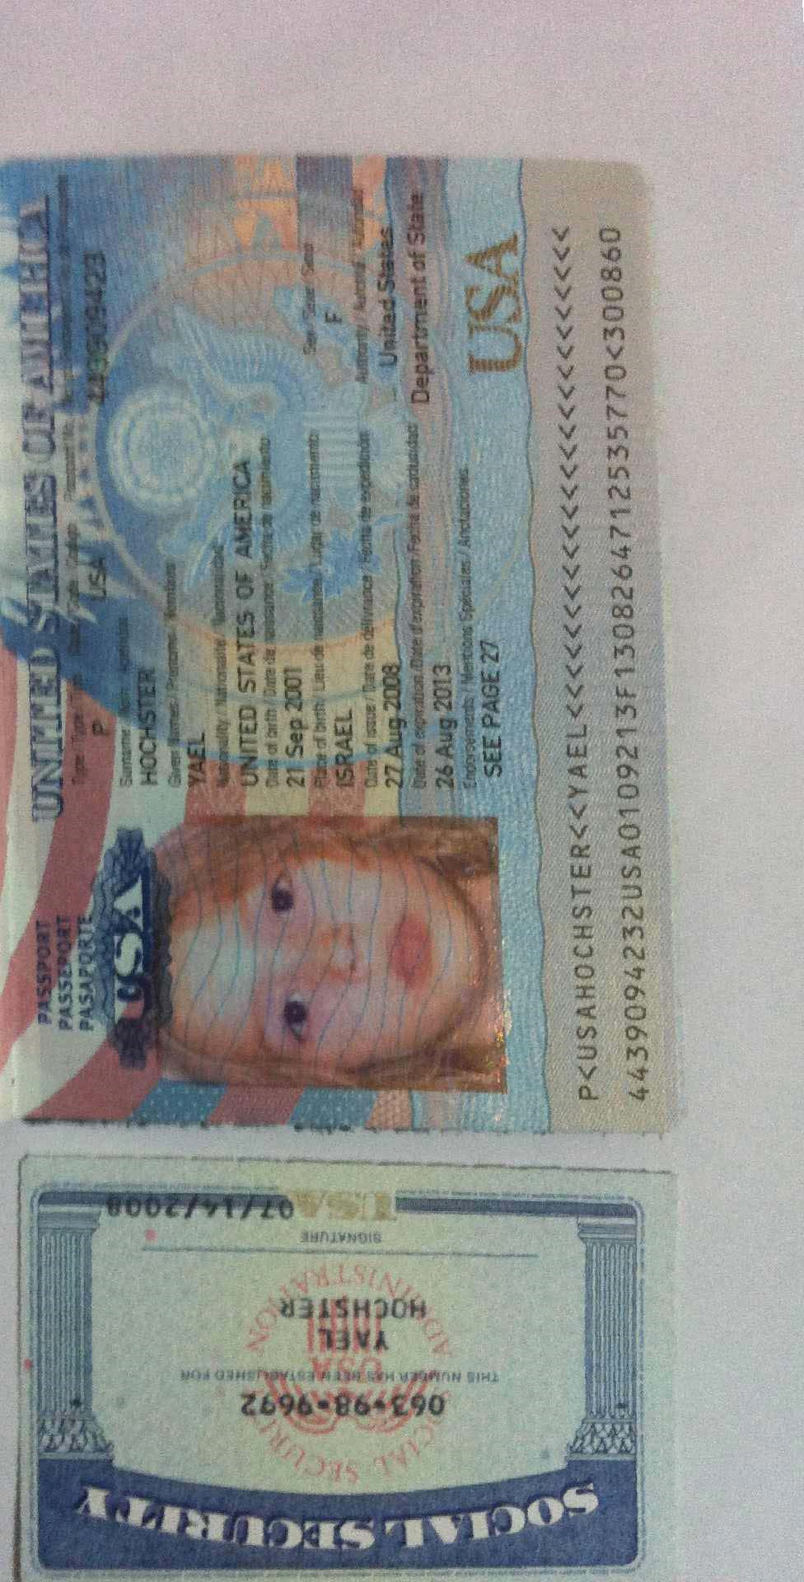
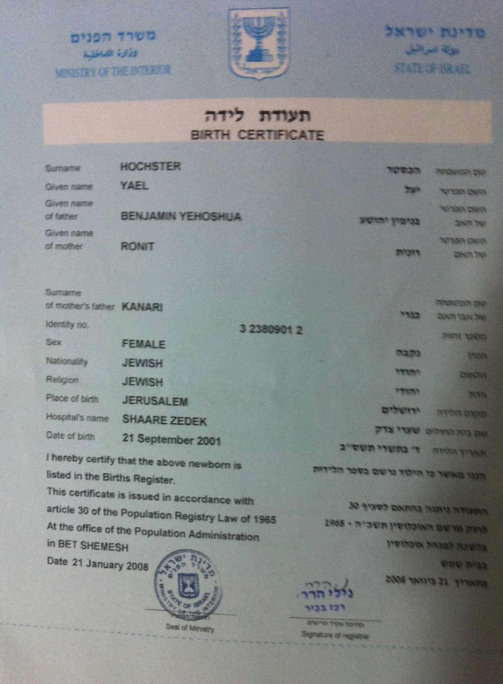
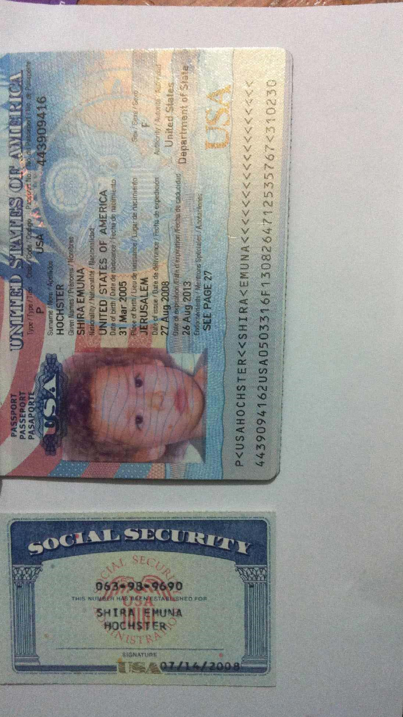
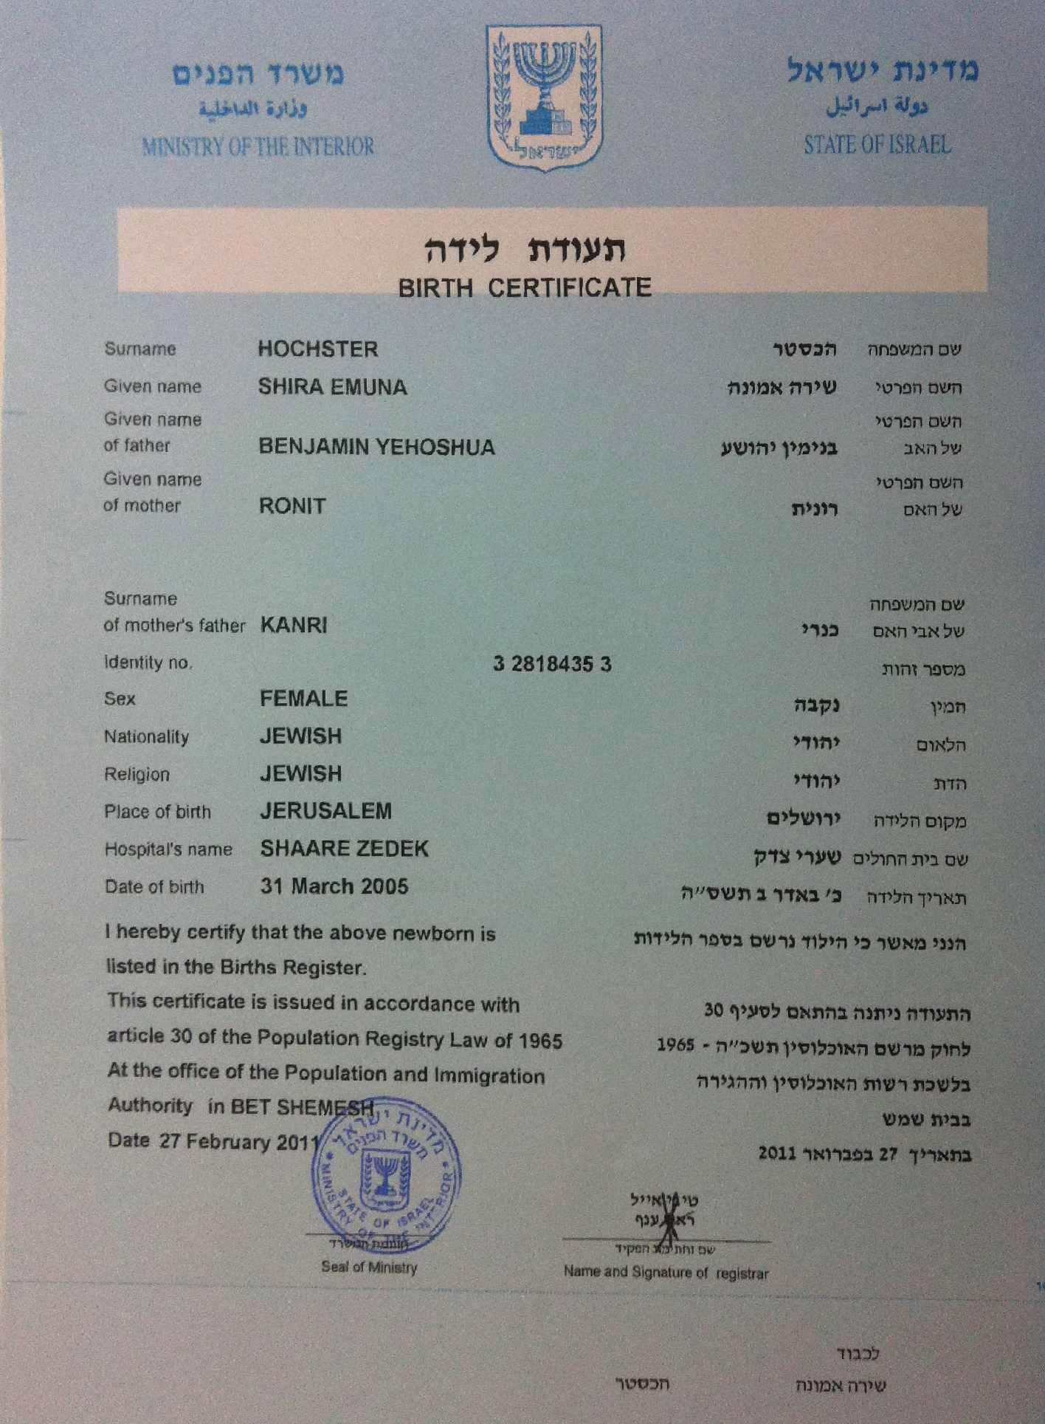
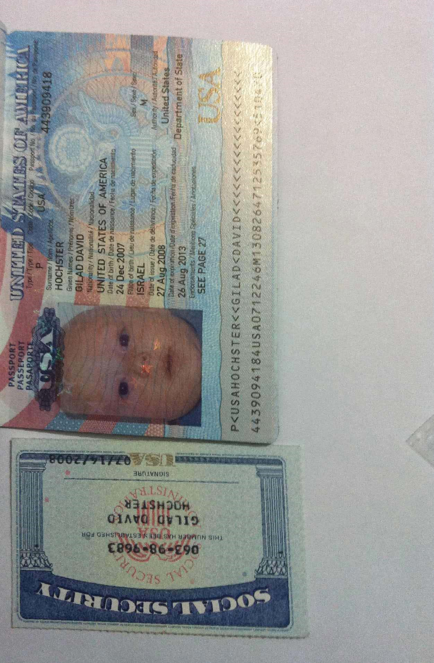
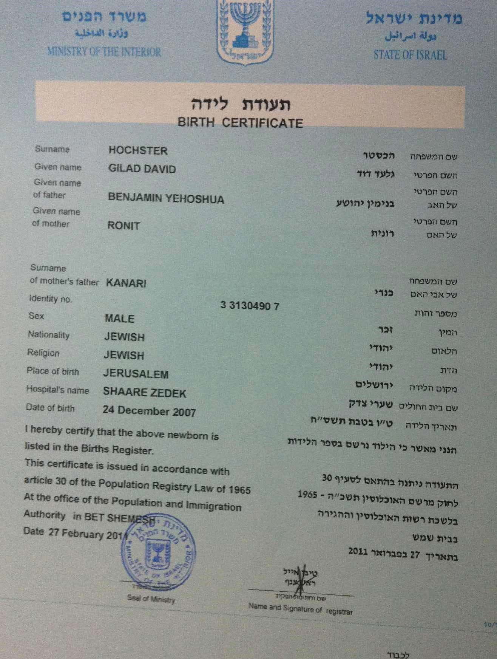

Benjamin J. Hochster Tel: +972-54-80-40-040
SSN: 063-98-7919 Ref: SE:LM:IN:C:FR:T2:T7

Information on Residence Address, Medical and School Records

- I have lived with my wife, Ronit Hochster, since we got married in 1997 (our marriage certificate, document #6).
- All my children lived with us at all times, since their births.
- We lived in the city of Bet Shemesh, Israel since 1997.
- Until 2006 we lived on 14 HaGalil st. Bet Shemesh, Israel. (see page 2 of the Extract from the Israeli Civil Registry, document #16)
- In late 2006 we moved to another address in Bet Shemesh: 34 Nachal Lachish st., where we are living ever since. (see page 2 of the Extract from the Israeli Civil Registry, document #16). 6. Documents #17 to #29 are copies and translations of medical records from each of the years 2006, 2007, 2008, for each child. I chose medical records that contain address reference of the child.
- Please note that since my youngest child, Gilad, was born in the last week of December 2007 (See his birth certificate above, document #14), I only have medical records on him for 2008.
- In the relevant years, only my 2 oldest children, Yoav and Yael, where of school age. So only they attended school, hence, this file contains letters from their schools, confirming their attendance in the years they attended. Shira was only 3 years old by 2008, and Gilad was only born at the end of 2007. Hence, I have no school records for them.

Address: 34 Nachal Lachish st.
Bet Shemesh
Israel 99093

State of Israel Ministry of Interior

Summary of Registration in the Civil Registry

Family Name: Hochster Private Name: Benjamin Joshua
Father's Private Name: Shimon Menachem
Mother's Private Name: Alta Aleeza
Sex: Male ID no: 028793339
Nationality: Jewish
Marital Status: Married
Country of Birth: Israel Place of Birth: Jerusalem
Hebrew Date of Birth: Cheshvan 15th 5732 Gregorian Date of Birth: November 3rd 1971
Residence: Bet Shemesh, 34 Nachal Lachish st., apt. 3, 99093
Date of Entry to Address : February 19th 2007
I hereby confirm that the above details are a correct summary of the civil registry.
This document was given with accordance to clause 29 of the civil registry law – 1965
At the Bet Shemesh office of the civil and immigration authority
On Febuary 17th 2011



Tibi Eyal (Signature) State of Israel
Stamp

Head of Branch . Ministry of Interior
Name and Signature Office Stamp

State of Israel Ministry of Interior

Continued Summary of Registration in the Civil Registry
Previous Residences:
Town | Street | House Entrance |  |  | Apt. | Entry Date
Town | Street | No. |  |  | Apt. | Entry Date
1. Bet Shemesh | HaGalil | 14 | b |  | 12 | December 29th 1997
2. Bet Shemesh | HaGalil | 14b |  |  | 12 | December 3rd 1997
3. Jerusalem | Hachish | 7 |  |  | 2 | July 23rd 1996
4. Alon Shvut | Alon Shvut |  |  |  |  | January 10th 1993
5 Jerusalem | Hachish | 7 |  |  |  | July 12th 1982
6. Jerusalem | Fichman

This document was given with accordance to clause 29 of the civil registry law – 1965
At the Bet Shemesh office of the civil and immigration authority
On February 17th 2011


Tibi Eyal (Signature) State of Israel
Stamp

Head of Branch . Ministry of Interior
Name and Signature Office Stamp

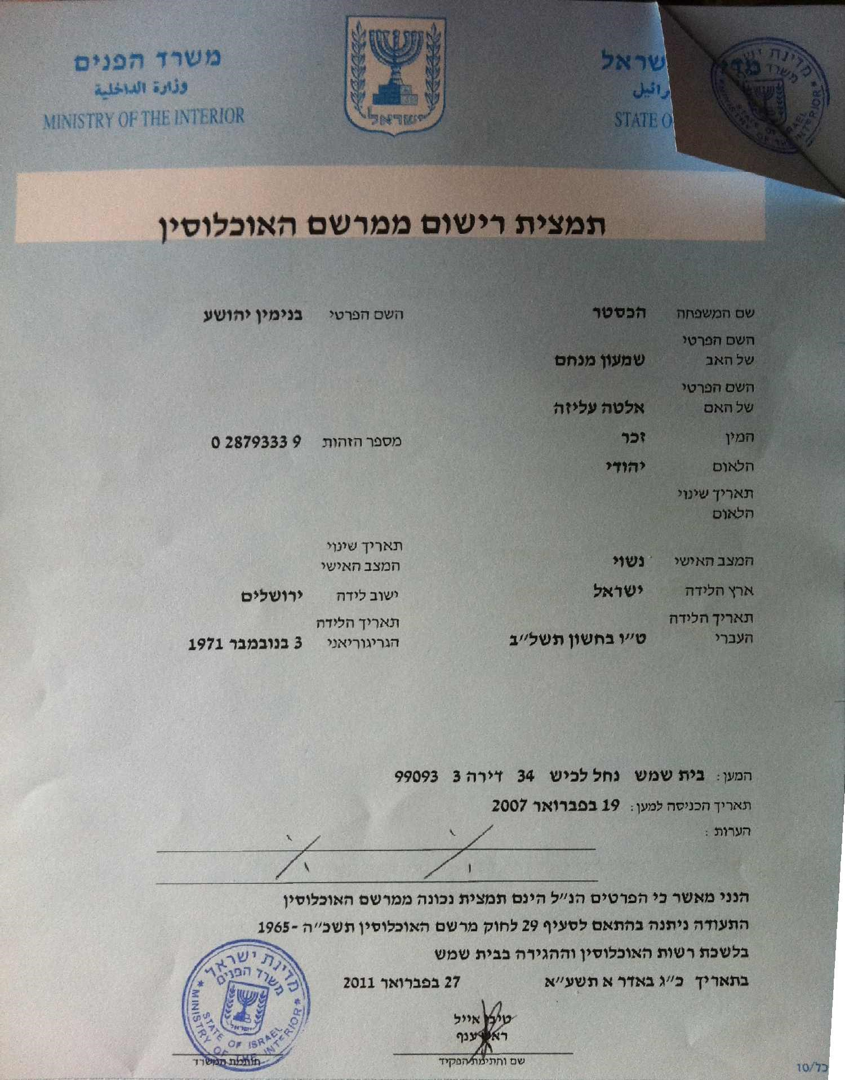
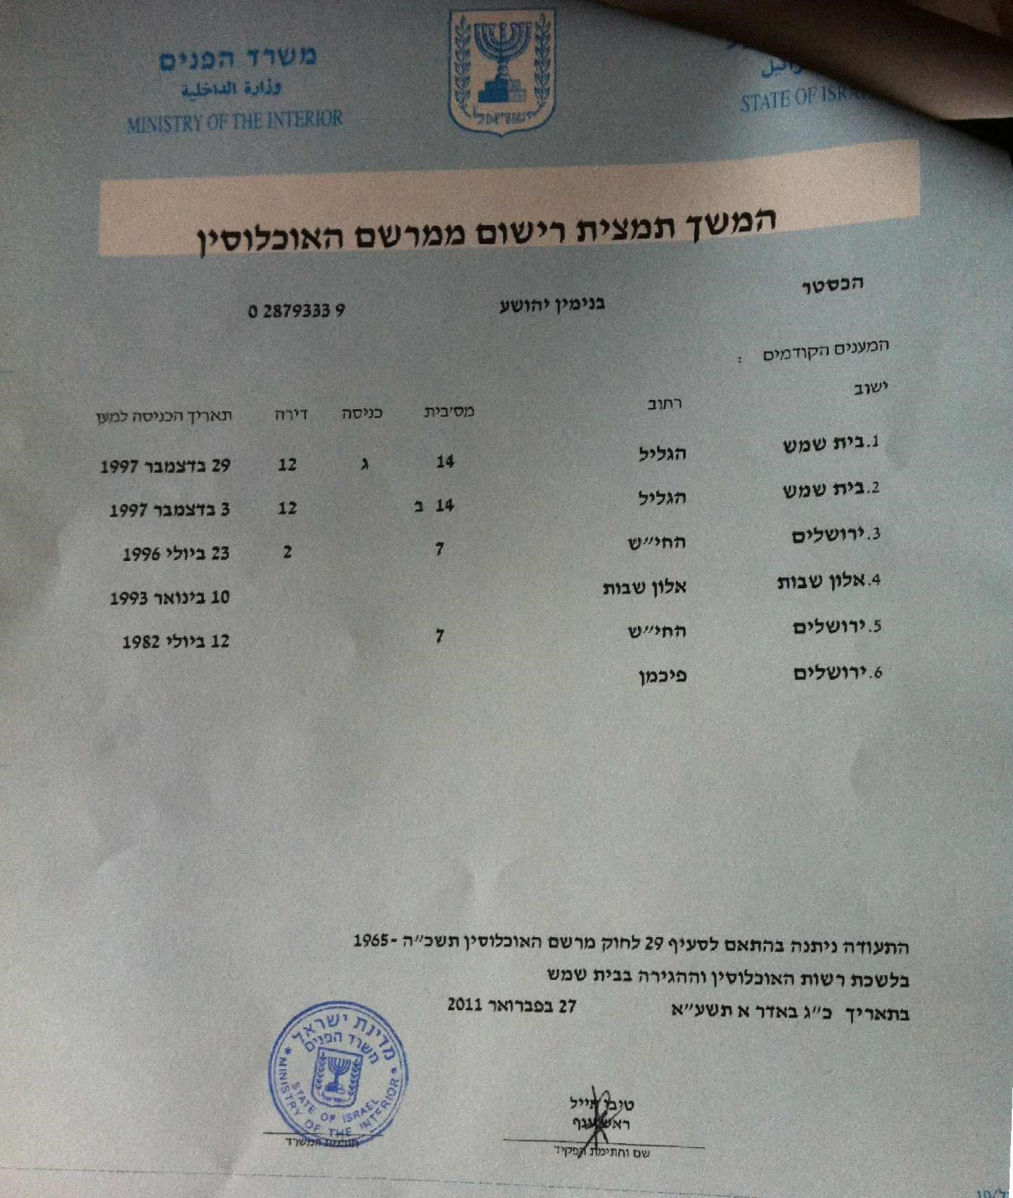

Macabi Health Services
Doctor Sultan J. Pediatrics
ID: 321117517 License No.: 32888
6 Zeelim st. Bet Shemesh
02-9906333

Member Visitation Confirmation no:72581

Mr./Ms. Hochster Yoav ID: 319030896
Address: Nachal Lachish st. 34 Bet Shemesh (Tel: 0029993029)

Visited the medical clinic on the date: 06/05/2008 at: 08:52 AM

A fee of 6 ILS will be charged to the bank account in the beginning of the next month, with accordance to payment policies.


Macabi Health Services "Macabi Kid" Clinic 38 Nachal Refaim st.
Tel. 02-6591250
(- signature -)

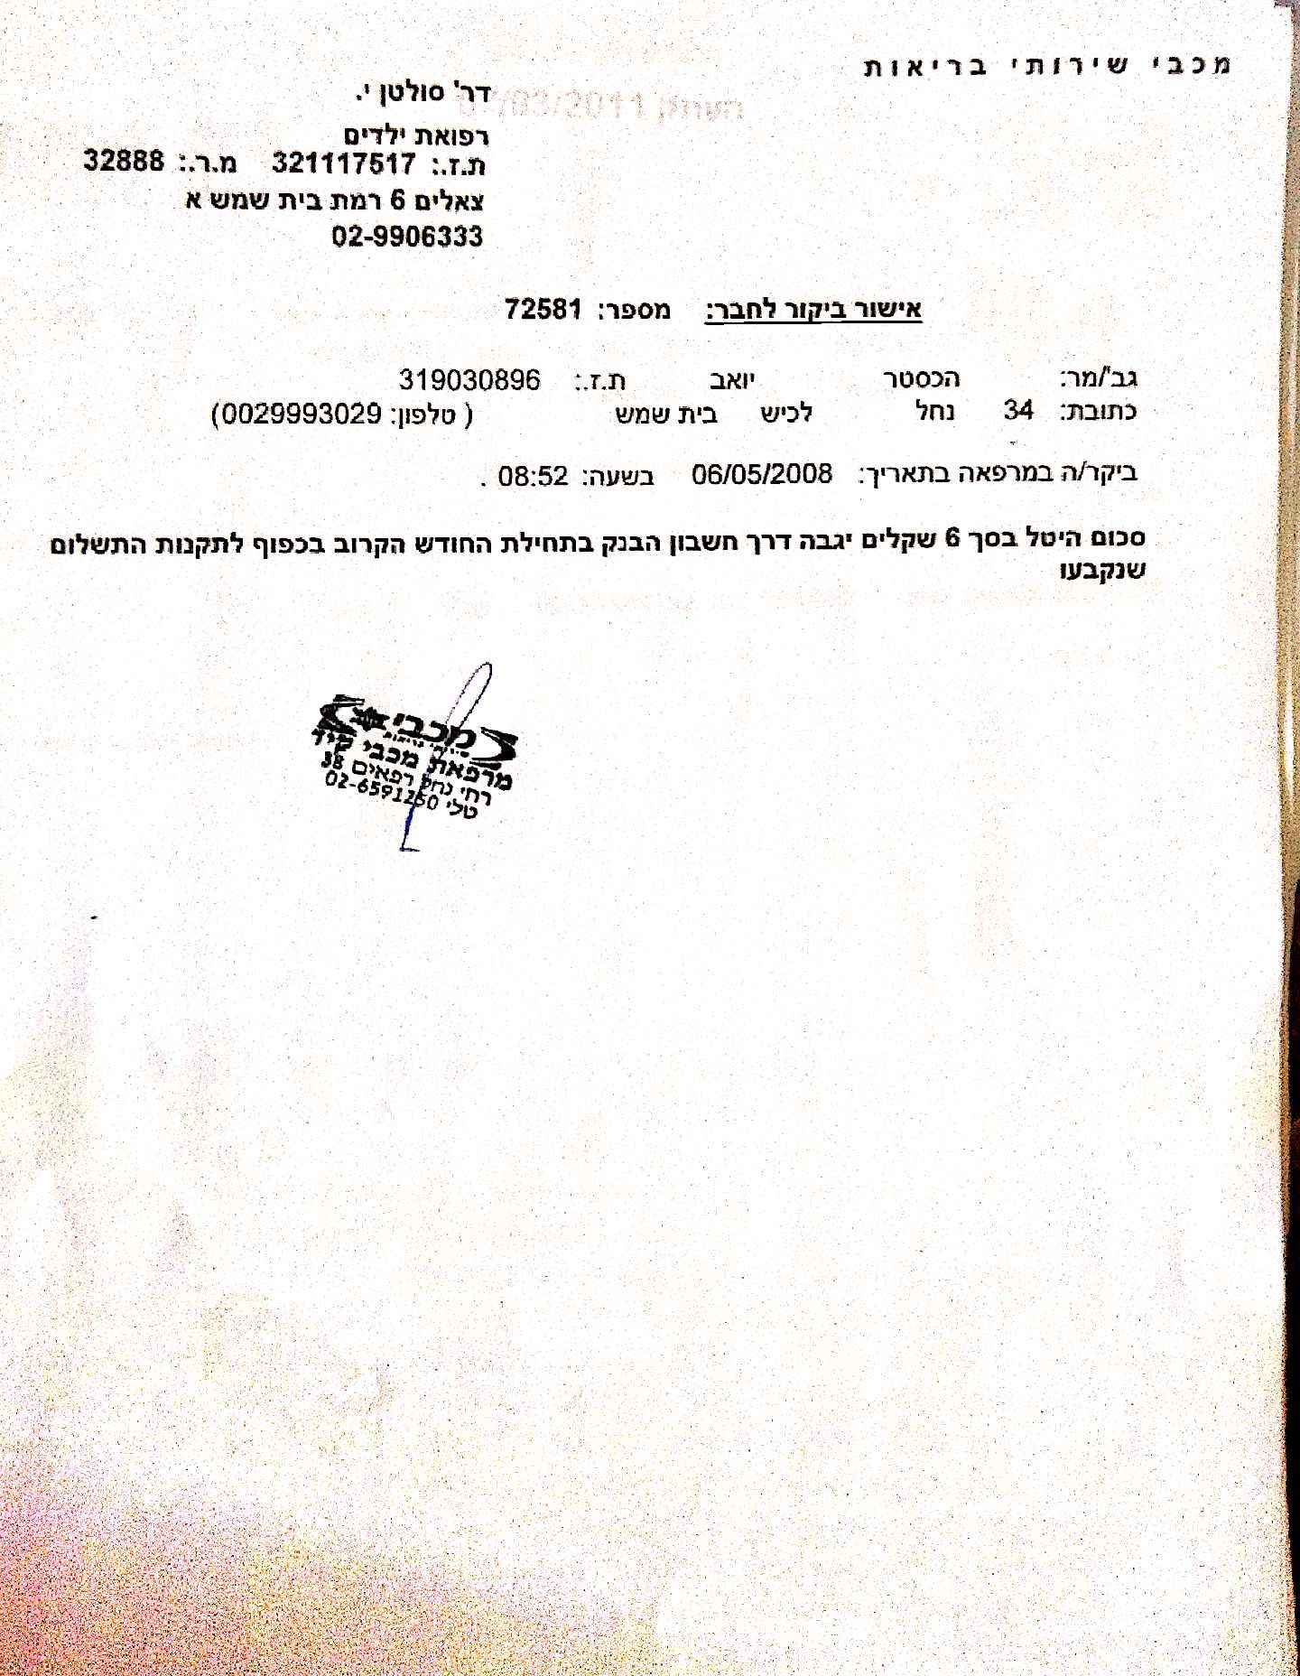

Macabi Health Services
Doctor Sultan J. Pediatrics
ID: 321117517 License No.: 32888
6 Zeelim st. Bet Shemesh
02-9906333

Member Visitation Confirmation no:12876

Mr./Ms. Hochster Yoav ID: 319030896
Address: Nachal Lachish st. 34 Bet Shemesh (Tel: 0029993029)

Visited the medical clinic on the date: 27/05/2007 at: 09:49 AM

A fee of 6 ILS will be charged to the bank account in the beginning of the next month, with accordance to payment policies.

Macabi Health Services "Macabi Kid" Clinic 38 Nachal Refaim st.
Tel. 02-6591250
(- signature -)

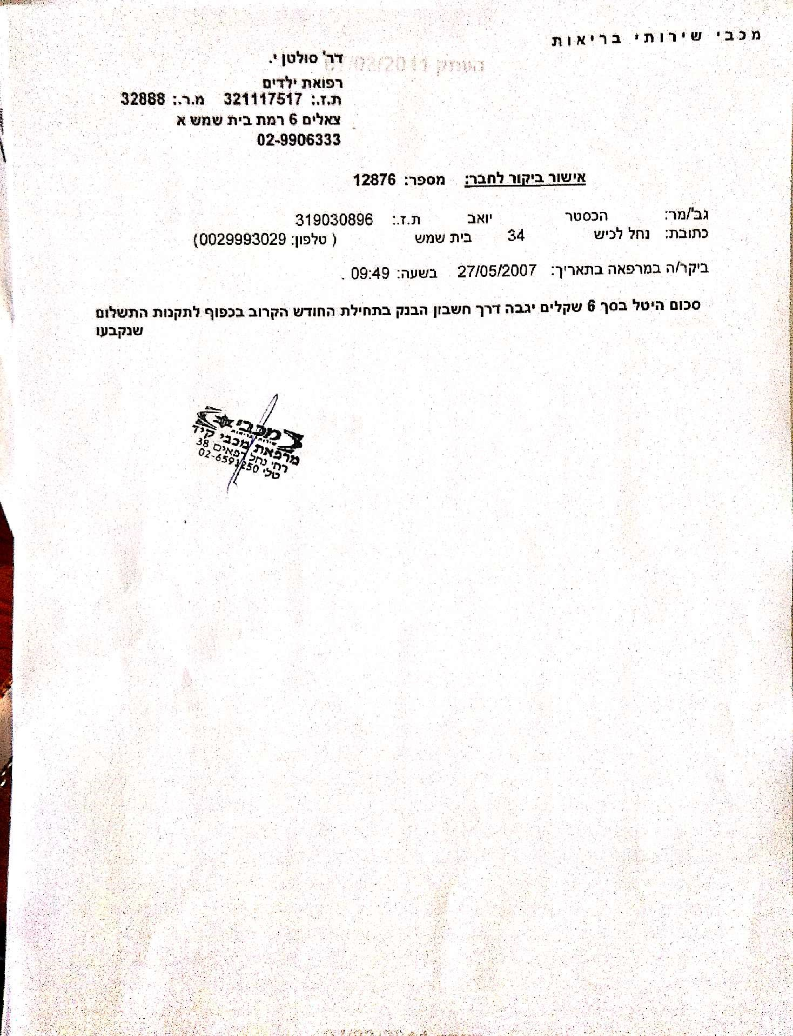

Macabi Health Services

Name of Referrer: Doctor Glustein J. License No.: 021670 0013761929
Specialty: Pediatrics
Address: 6 Zeelim st. Bet Shemesh
Tel: 9906333

Family Name: Hochster First Name: Yoav ID: 319030896 DOB : 17/09/1999 Sex: m Tel: 0029993029 Address: HaGalil st. 14 Bet Shemesh.

Confirmation of the child's illness

Suffers from:

• Tonsillitis Acute

And requires attendance of mother/father from 28/12/2006 until 28/12/2006, 1 day in total

28/12/2006 _____________________________ Date Doctor's Stamp and Signature

Macabi Health Services
"Macabi Kid" Clinic
38 Nachal Refaim st.
Tel. 02-6591250
(- signature -)

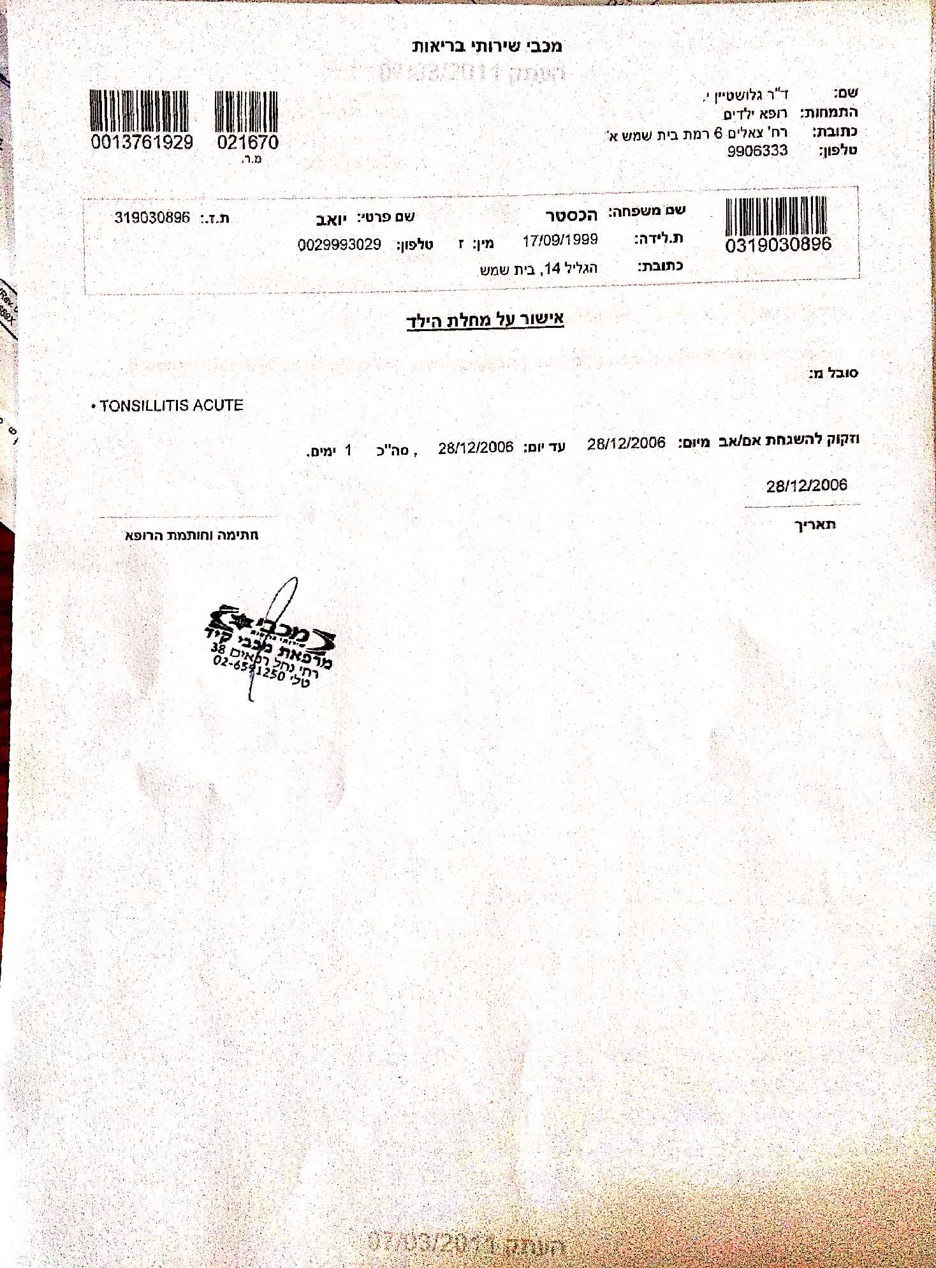

Macabi Health Services
Doctor Sultan J. Pediatrics
ID: 321117517 License No.: 32888
6 Zeelim st. Bet Shemesh
9906333

Member Visitation Confirmation no:71002

Mr./Ms. Hochster Yael ID: 323809012
Address: Nachal Lachish st. 34 Bet Shemesh (Tel: 0029993029)

Visited the medical clinic on the date: 17/08/2008 at: 10:29 AM

A fee of 6 ILS will be charged to the bank account in the beginning of the next month, with

accordance to payment policies.

Macabi Health Services "Macabi Kid" Clinic 38 Nachal Refaim st.
Tel. 02-6591250
(- signature -)

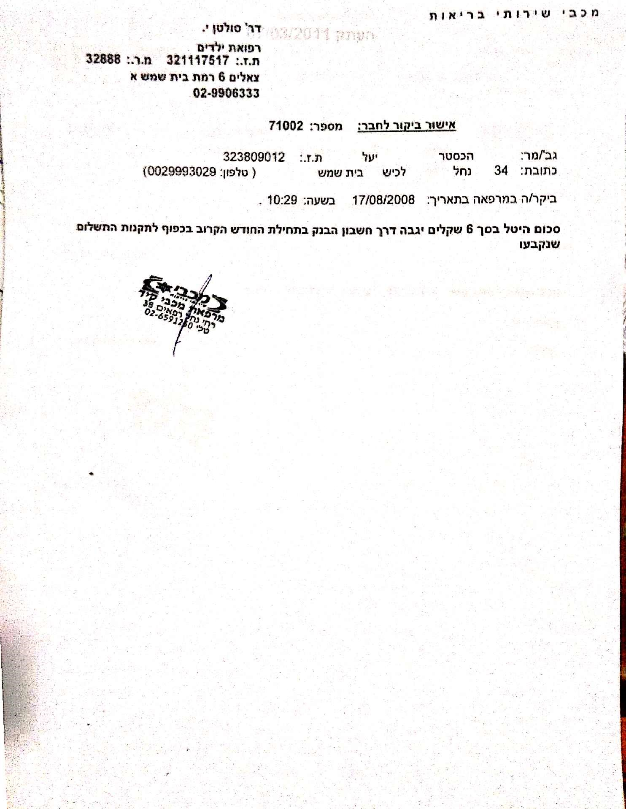

Macabi Health Services

Name of Referrer: Doctor Sultan J. License No.: 032888 0321117517
Specialty: Pediatrics
Address: 6 Zeelim st. Bet Shemesh
Tel: 9906333

Subject's Details: 0323809012
Family Name: Hochster First Name: Yael  DOB: 21/09/2001 Sex: f Tel: 0029993029 | ID: 323809012
Address: Nachal Lachish st. 34 Bet Shemesh. | Zip:99093

Confirmation of the child's illness

Suffers from:

• Vomiting

And requires attendance of mother/father from 24/12/2007 until 24/12/2007, 1 day in total

24/12/2007 _____________________________
Date Doctor's Stamp and Signature

Macabi Health Services "Macabi Kid" Clinic
38 Nachal Refaim st.
Tel. 02-6591250
(- signature -)

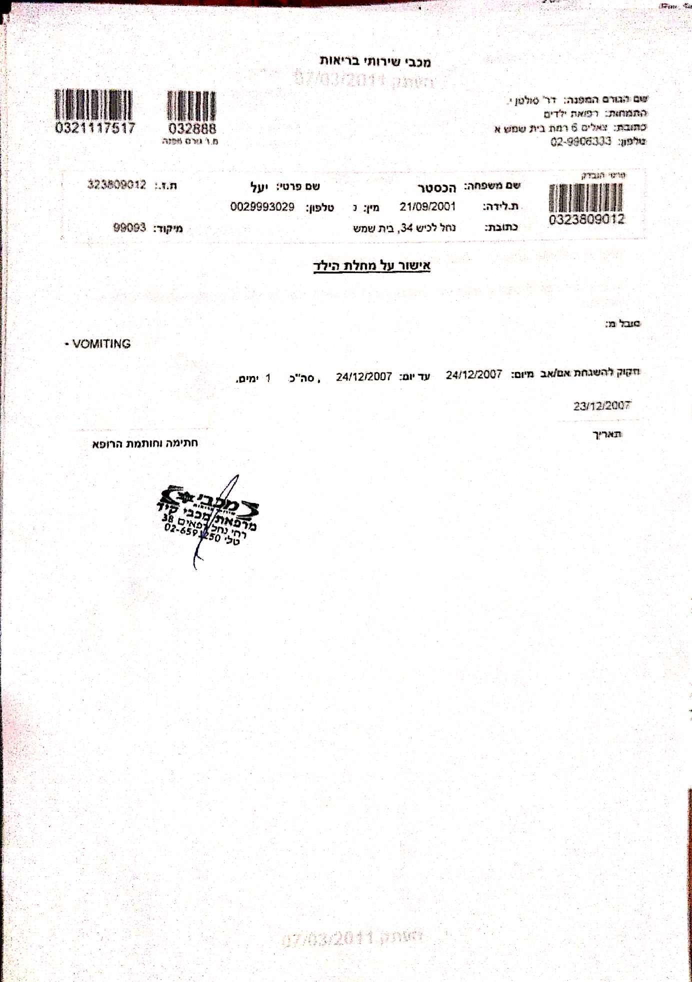

Macabi Health Services
Doctor Sultan J. Pediatrics
ID:321117517 License No.: 32888
6 Zeelim st. Bet Shemesh
9906333

Member Visitation Confirmation no:77424

Mr./Ms. Hochster Yael ID: 323809012
Address: HaGalil 14 Bet Shemesh (Tel: 0029993029)

Visited the medical clinic on the date: 15/10/2006 at: 09:04 AM

A fee of 6 ILS will be charged to the bank account in the beginning of the next month, with accordance to payment policies.

Macabi Health Services "Macabi Kid" Clinic 38 Nachal Refaim st.
Tel. 02-6591250
(- signature -)

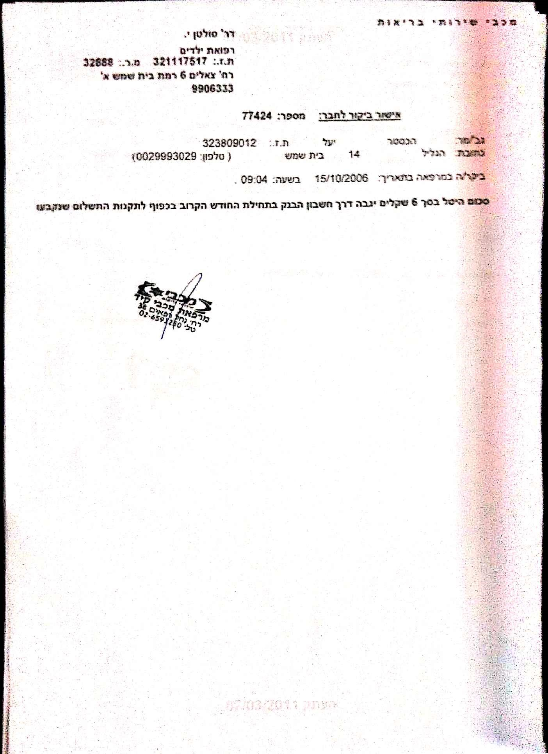

Macabi Health Services
Doctor Shamrot R.
Skin and Sex
ID:319368148 License No.: 31005
6 Zeelim st. Bet Shemesh
02-9906333

Member Visitation Confirmation no:67606

Mr./Ms. Hochster Shira Emu ID: 328184353
Address: Nachal Lachish st. 34 Bet Shemesh (Tel: 0029993029)

Visited the medical clinic on the date: 12/08/2008 at: 13:48 PM

A fee of 19 ILS will be charged to the bank account in the beginning of the next month, with accordance to payment policies.

Macabi Health Services "Macabi Kid" Clinic 38 Nachal Refaim st.
Tel. 02-6591250
(- signature -)

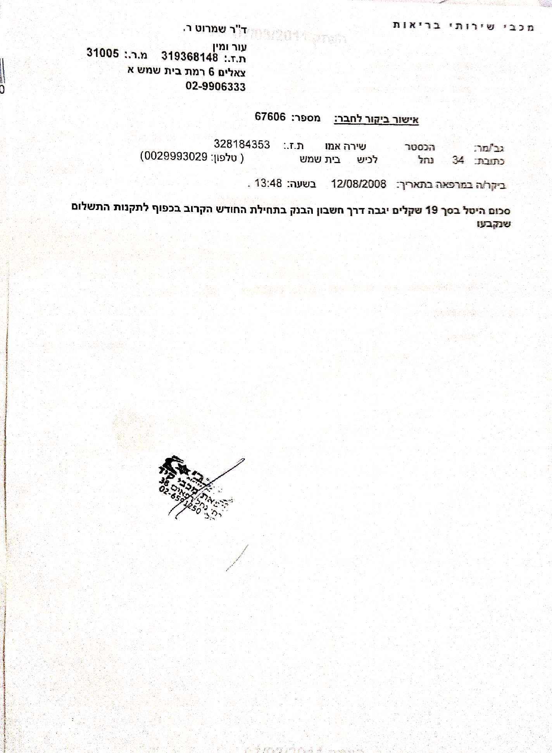

Name of Referrer: Doctor Glustein J. License No.: 021670 0013761929
Specialty: Pediatrics
Address: 6 Zeelim st. Bet Shemesh
Tel: 9906333

Subject's Details:
0328184353
Family Name: Hochster First Name: Shira Emu ID: 328184353
DOB: 31/03/2005 Sex: f Tel: 0029993029
Address: Nachal Lachish st. 34 Bet Shemesh. Zip:99093

Confirmation of the child's illness

Suffers from:

• Fever

And requires attendance of mother/father from 04/06/2007 until 04/06/2007 , 1 day in total

03/06/2007 _____________________________ Date Doctor's Stamp and Signature

Macabi Health Services "Macabi Kid" Clinic 38 Nachal Refaim st.
Tel. 02-6591250
(- signature -)

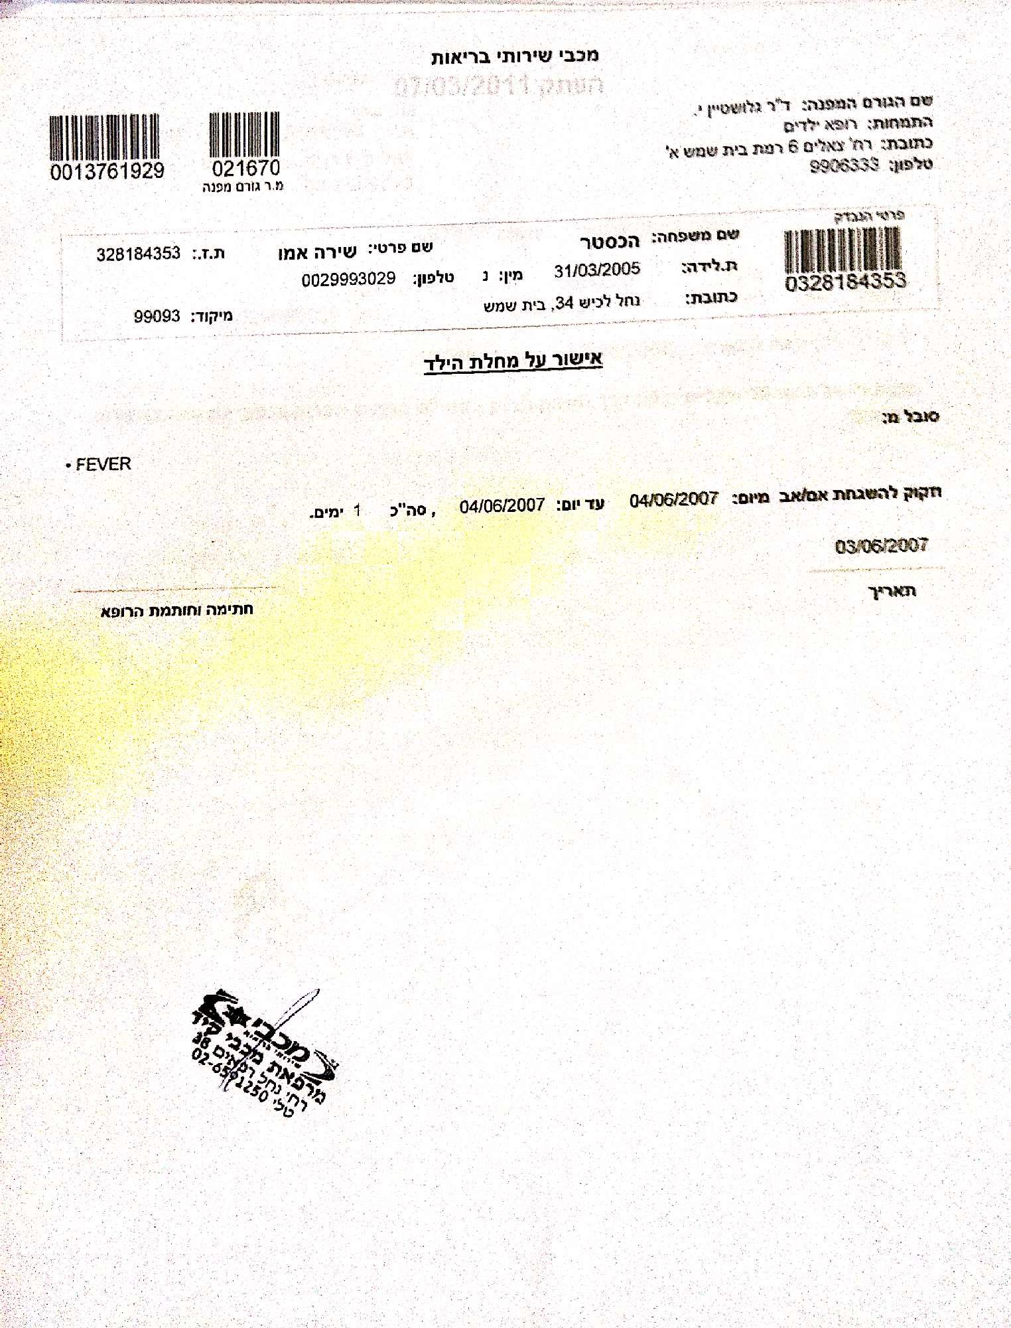

Name: Doctor Karshai David License No.: 020723 0055709554
Specialty: Pediatrics
Address: 15 Chativat Harel st.
Tel: 9917587

Family Name: Hochster First Name: Shira Emuna ID: 328184353
DOB: 31/03/2005 Sex: f Tel: 0029993029 Address: 14 HaGalil st. Bet Shemesh.

Confirmation of the child's illness

Suffers from:

• Viral Infections UNS

And requires attendance of mother/father from 20/02/2006 until 20/02/2006, 1 day in total

22/02/2006 _____________________________ Date Doctor's Stamp and Signature

Macabi Health Services
"Macabi Kid" Clinic 38 Nachal Refaim st.
Tel. 02-6591250
(- signature -)

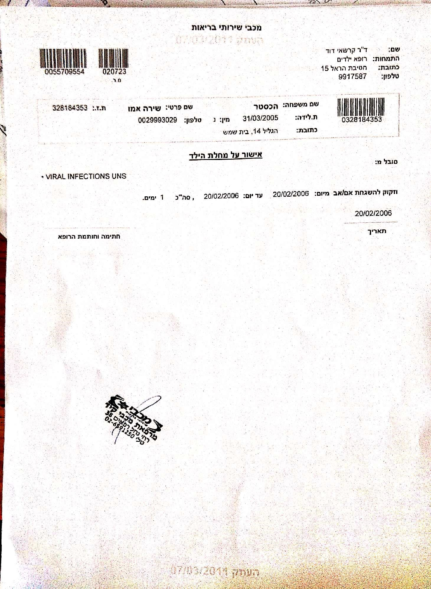

Name of Referrer: Doctor Sultan J. License: 032888 0321117517
Specialty: Pediatrics
Address: 6 Zeelim st. Bet Shemesh
Tel: 9906333

Subject's Details:
0331304907
Family Name: Hochster First Name: Gilad David ID: 331304907 DOB: 24/12/2007 Sex: m Tel: 0029993029
Address: Nachal Lachish st. 34 Bet Shemesh. Zip:99093

Confirmation of the child's illness

Suffers from:

• URI

And requires attendance of mother/father from 25/05/2008 until 25/05/2008, 1 day in total

25/05/2008 _____________________________ Date Doctor's Stamp and Signature

Macabi Health Services
"Macabi Kid" Clinic 38 Nachal Refaim st.
Tel. 02-6591250
(- signature -)

